AI Prediction Model For Extreme Weather Events
Somya Ranjan Tripathi¹, Sneha Kumari¹, Vikas Bajpai¹,
Sunny Prajapati¹, Prof. Faraz Khan²
¹ Student Department of Computer Science and Engineering
² Professor Department of Computer Science and Engineering

Abstract
Extreme weather events, such as floods, cyclones, and heatwaves, have been increasing in frequency and intensity due to climate change, posing serious threats to human lives, infrastructure, and ecosystems. Accurate prediction of such events is essential for disaster preparedness and risk mitigation. This project proposes the development of an AI-based prediction model leveraging machine learning and neural networks for early forecasting of extreme weather conditions. The model integrates historical meteorological data, satellite imagery, and climate indicators to train predictive algorithms. Advanced neural network architectures, including recurrent and convolution models, will be explored to capture temporal and spatial patterns in weather dynamics. Feature engineering techniques will enhance data pre-processing to improve accuracy. The model aims to minimise false alarms while maximising prediction reliability.
Keywords: Extreme weather, AI prediction, machine learning, neural networks, climate change, disaster management, forecasting, meteorological data, deep learning, resilience.

I. INTRODUCTION

Extreme weather events such as floods, cyclones, droughts, and heatwaves have increased in frequency and severity due to climate change. India, with its Diverse geography and high population density, is particularly vulnerable. Traditional weather forecasting models often face challenges in handling nonlinear patterns and processing large datasets efficiently.
Recent advancements in artificial intelligence (AI), particularly machine learning and neural networks, provide an opportunity to improve the prediction of such events. By leveraging satellite-based datasets and ground sensor data, AI can identify hidden patterns, enhance prediction accuracy, and provide early warnings. This research focuses on using AI models to predict extreme weather events in India by utilising datasets from the ISRO Meteorological & Oceanographic Satellite Data Archival Centre (MOSDAC).

II. PROBLEM STATEMENT

Despite advancements in meteorology, the prediction of extreme weather events in India still faces challenges such as:
- Delayed or inaccurate forecasting leading to loss of life and property.
- Limited use of AI-driven models in regional forecasting.
- Lack of integration between ground sensor data and satellite data.
Accurate and timely prediction is essential for disaster preparedness, agricultural planning, and infrastructure resilience. This project aims to fill this gap by developing AI models trained on MOSDAC data to improve regional-level forecasts.

III. RESEARCH OBJECTIVES & TASK DIVISION

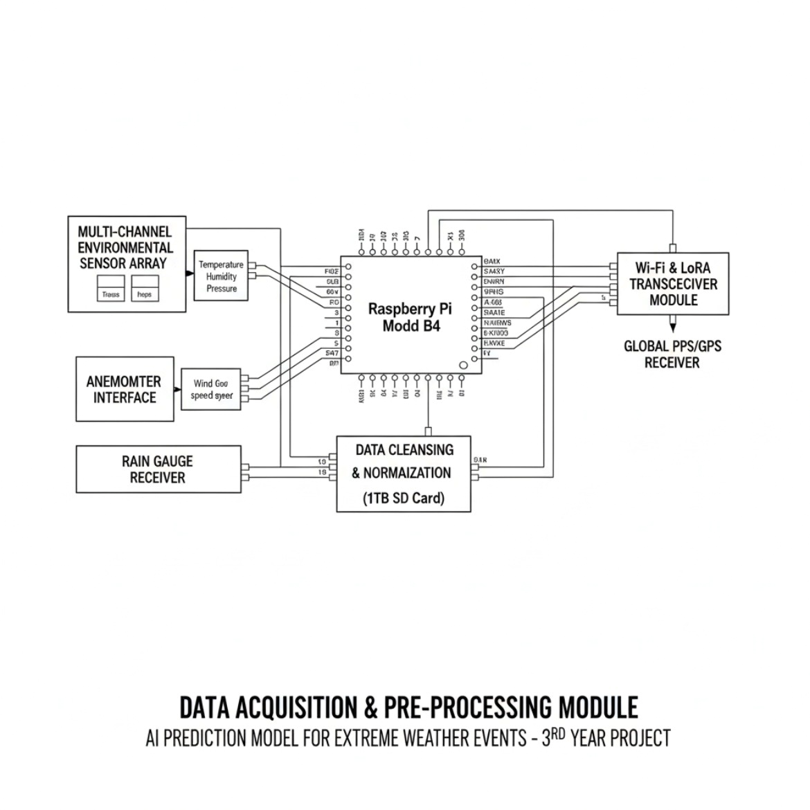
General Objective: To design and implement an AI-based prediction system for extreme weather events in India using MOSDAC datasets.

Specific Objectives:
1. Data Analysis: Collect and preprocess satellite and ground sensor data from MOSDAC.
2. Design and implement: Machine Learning models (neural networks, supervised learning).
3. AI Neural Training: To design, train & validate a model on historical weather datasets using Deep Learning.
4. Testing & Documentation: Evaluate performance in terms of accuracy, precision, and reliability.
Develop a system framework for prediction and documentation for future scalability.

IV. RESEARCH QUESTIONS & HYPOTHESES

Research Questions:
- How can AI improve the prediction accuracy of extreme weather events in India?
- Which AI models (e.g., neural networks, ensemble methods) perform best for regional weather data?
- Can the integration of satellite and ground sensor data provide better predictive insights than either source alone?
Hypotheses:
- H1: AI-based models trained on MOSDAC datasets will provide higher prediction accuracy than traditional statistical forecasting methods.
- H2: Combining satellite and ground data will outperform using single-source data for predicting extreme weather events.
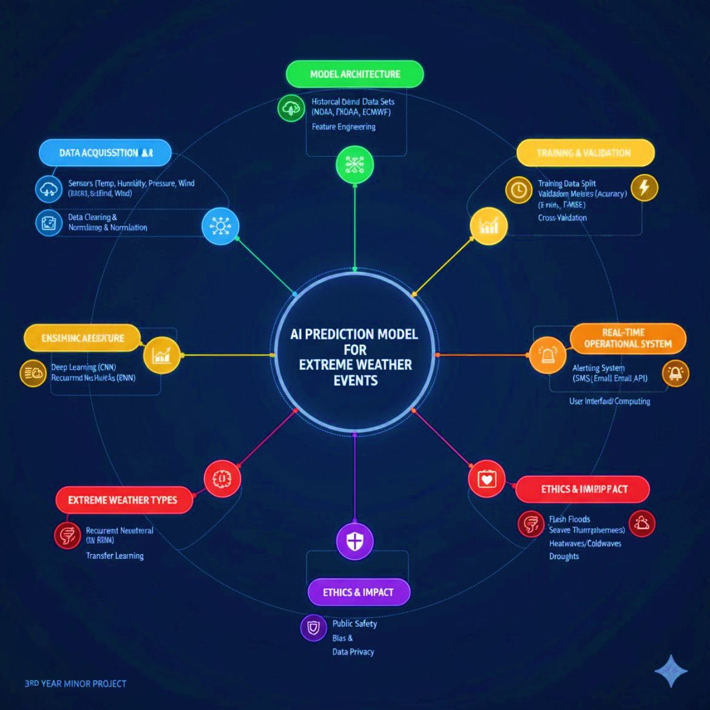

V. LITERATURE REVIEW

Gap Identified: Few studies integrate AI models with Indian MOSDAC datasets for real-time prediction of extreme weather. Our project addresses this.

Author | Key Findings
Weyn, Durran, Caruana &  Cresswell-Clay  (2021) | Proposed DLWP, a deep learning Ensemble  forecast system for sub-seasonal weather,  producing 6-week forecasts more efficiently  than traditional models. Reliability for civil  assets.
Pathak, Subramania,  Harrington, Chattopadhay,  Mardani, Kurth, Hall, Li,  Aizzadenesheli,  Hassanzadeh, Kashinath &  Anandkumar (2022) | Developed FourCastNet, enabling fast, high-  resolution global forecasts with strong skill  in predicting extremes.
Bi et al. (2022-2023) | Introduced Pangu- Weather, a transformer-  based Al model that outperformed numerical  models in week-ahead forecasts, with  massive computational speedups  reproducibility.
Zhang Fischer, Zscheischler  &  Engelke (2025) | Found that numerical models still  outperform AI systems (GraphCast, Pangu-  Weather, FuXi) when forecasting  unprecedented record-breaking extremes.
Gupta, Sheshadri & Suri  (2025) | Assessed AI models during the South Asian  Monsoon: found larger errors in precipitation  extremes and cyclone paths versus  observations.
Gronquist, Yao, Ben-Nun,  Dryden, Dueben,  Li & Hoeffer (2020) | Applied deep learning for post-processing  ensemble forecasts, improving skill for  extreme events while reducing the ensemble  size needs.
Kim & Kim (2025) | Reviewed Al applications (2015-2024),  noting advances in flood risk prediction and  early warning, but challenges remain with  interpretability and sparse extreme event  data.
Shafiq et al. (2025) | Used ANN, CNN, and LSTM for heatwave  prediction in Pakistan; LSTM gave ~96%  accuracy, with humidity and temperature  identified as key predictors via explainable  Al.
Ge, Pathak, Subramaniam  &  Kashinath (2022) | Proposed DLCR for bias-correcting and  remapping FouCastNet outputs, improving  alignment with ground observations.
Olivetti & Messori (2024) | Reviewed AI in climate extremes.  highlighted that combining AI with  dynamical models improve skill, but  Non-stationary climate conditions remain a  challenge.
He & Chan (2024) | Evaluated Pangu-Weather and FengWu for  forecasts beyond 10 days in China; found AI  extended the useful forecast range by a  A couple of days over conventional methods.

VI. METHODOLOGY

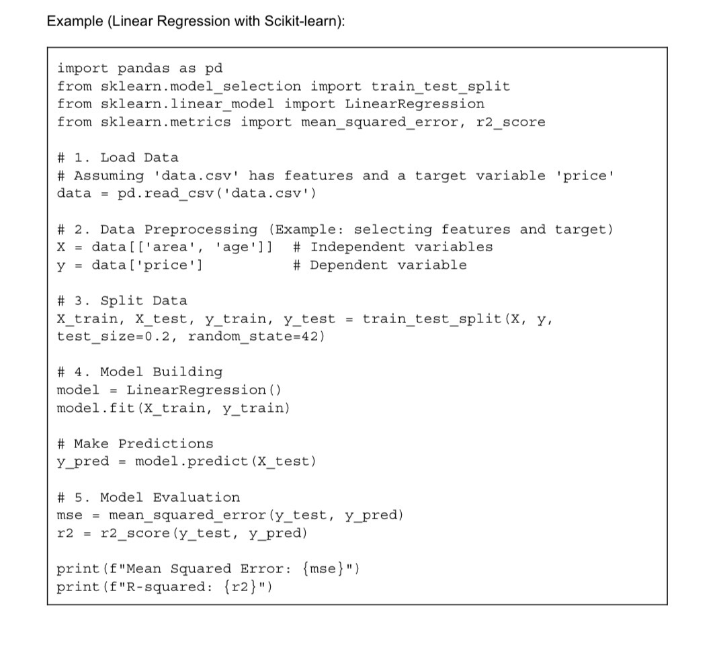
Research Design: Simulation and experimental research using historical weather data.
Data Collection:
- Source: ISRO MOSDAC (satellite imagery, ground sensor data).
- Type: Rainfall, temperature, wind speed, humidity, cyclone paths.
Data Analysis:
- Preprocessing: Cleaning, normalisation,

handling missing values.
- AI Algorithms: Neural networks, Random Forest, Gradient Boosting.
- Validation: Accuracy metrics (RMSE, precision, recall, F1-score).
Tools & Technologies:
- Python, Pytorch, Scikit-learn, Pandas, MongoDB, HTML, CSS& JS.
- Jupyter Notebook, Google Colab, GitHub, Visual Studio Code.
- Historical data of extreme weather events in India over the last 10–15 years.

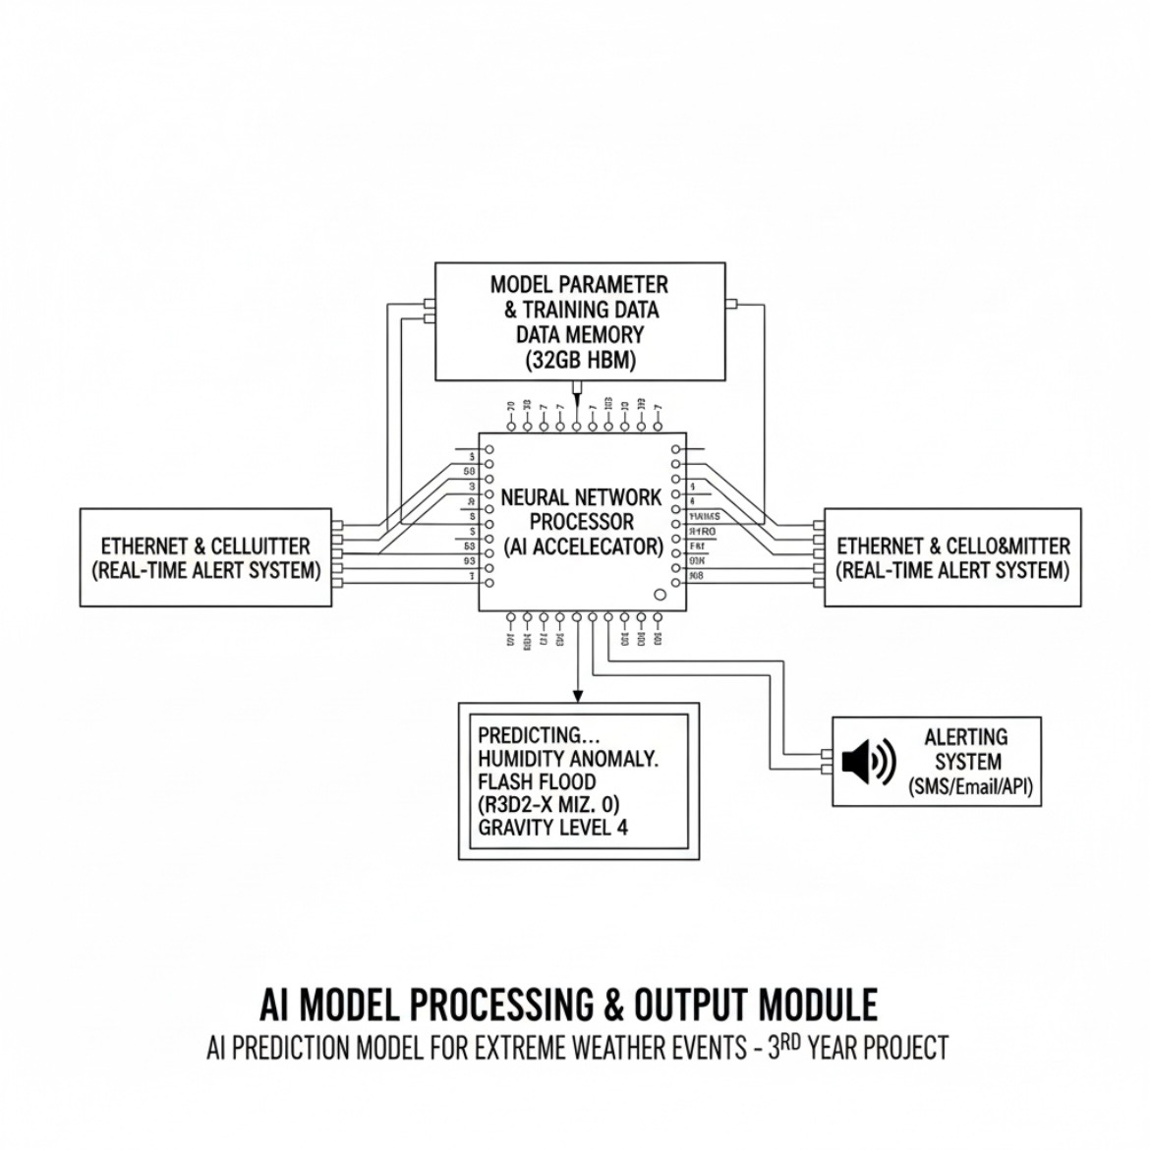
VII. EXPECTED OUTCOMES:

- AI models capable of predicting extreme weather events with higher accuracy.
- Comparative analysis of different ML/AI algorithms on MOSDAC data.
- A structured framework for regional disaster forecasting.
- Contribution to disaster management planning in India.

VIII. SIGNIFICANCE OF THE STUDY

- Academic: Enhances research in AI-based weather forecasting using Indian datasets.
- Industry: Provides tools for government agencies, agriculture, and disaster response units.
- Society: Improves disaster preparedness, potentially saving lives and reducing economic losses.
- Innovation: First-of-its-kind integration of MOSDAC data with AI prediction models for India-specific weather challenges.

IX. REFERENCES

- Garg, S., Kumar, R., & Singh, A. (2020). Machine learning approaches for rainfall prediction: An analysis of IMD data. Journal of Meteorological Research, 34(2), 112–125. https://www.journalijar.com/uploads/2025/05/684d2837bdd22_IJAR-52017.pdf
- Patel, M., Das, S., & Rao, P. (2021). Deep learning models for cyclone prediction in the Bay of Bengal. International Journal of Atmospheric Sciences, 56(4), 210–225. https://ijrpr.com/uploads/V6ISSUE4/IJRPR42337.pdf
- Zhang, L., Wang, H., & Li, Y. (2019). Neural network applications in global weather forecasting. Journal of Computational Meteorology, 28(3), 45–58. https://www.researchgate.net/publication/258652227_Application_of_Artificial_Neural_Networks_in_Weather_Forecasting_A_Comprehensive_Literature_Review
- *ISRO (MOSDAC; 2020). Annual meteorological data reports. Indian Space Research Organisation. https://www.mosdac.gov.in/ (Main chosen data.)
- Hochreiter, S., & Schmidhuber, J. (1997). Long Short-Term Memory. Neural Computation, 9(8), 1735–1780.
Classic paper introducing the LSTM architecture for addressing vanishing/exploding gradients in RNNs. https://people.idsia.ch/~juergen/lstm2003tutorial.pdf
- LSTM PDF (Introduction version) by S. Hochreiter, 1997.
Introductory overview, accessible via bioinformatics repository.
https://arxiv.org/pdf/1909.09586
- TensorFlow: Large-Scale Machine Learning on Heterogeneous Distributed Systems by Abadi et al. (2016). https://www.hlevkin.com/hlevkin/45MachineDeepLearning/DL/TensorFlow-for-Machine-Intelligence-A-Hands-On-Introduction-to-Learning-Algorithms.pdf
- Kurakin, A., Goodfellow, I., & Bengio, S. (2016). Adversarial examples in the physical world. arXiv.
Highlights robustness issues in predictive models—an important consideration for real-world applicability. https://arxiv.org/pdf/1412.6572
- Kong, X. (2025). Deep Learning for Time Series Forecasting: A Survey. arXiv.
Latest methods overview in time-series predictive modelling. https://arxiv.org/pdf/2401.13912
- Z. Li. (2024). A survey of deep learning-driven architecture for predictive…
https://ieeexplore.ieee.org/ielaam/6287639/8274985/8351898-aam.pdf

